Task 4

SUID & Privilege Escalation

Setup:



1. The command sets the SUID (Set User ID) bit on /bin/bash , enabling it to execute with the owner's (root) privileges.



2. Create a script with root privileges ➤ The 4755 permission setting ensures the following:

~4 → Sets the SUID (Set User ID) bit.

~7 → Grants the owner read ( r ), write ( w ), and execute ( x ) permissions.

~5 → Grants the group read ( r ) and execute ( x ) permissions.

~5 → Grants others read ( r ) and execute ( x ) permissions.

Exploit:

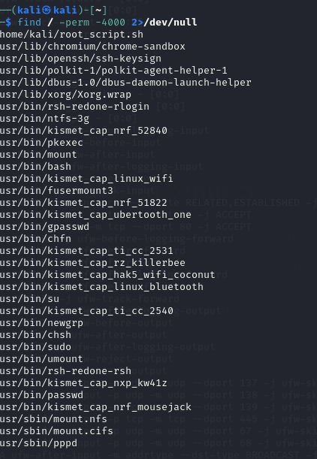

To identify SUID misconfigurations, use the command find / -perm -4000 2>/dev/null , which lists files with the SUID bit set while suppressing error messages from inaccessible directories. To escalate privileges to root, execute /bin/bash -p , where the -p flag ensures the shell retains elevated privileges, granting root access.

Mitigation:



To enhance security, remove unnecessary SUID permissions using chmod -s /bin/bash , and restrict script execution to specific users by adjusting file ownership with chown root:trusted_user root_script.sh command.